Functional Model
AI Clinic Visit Planner
By
Kiran Gankidi

1. Use Case Diagram
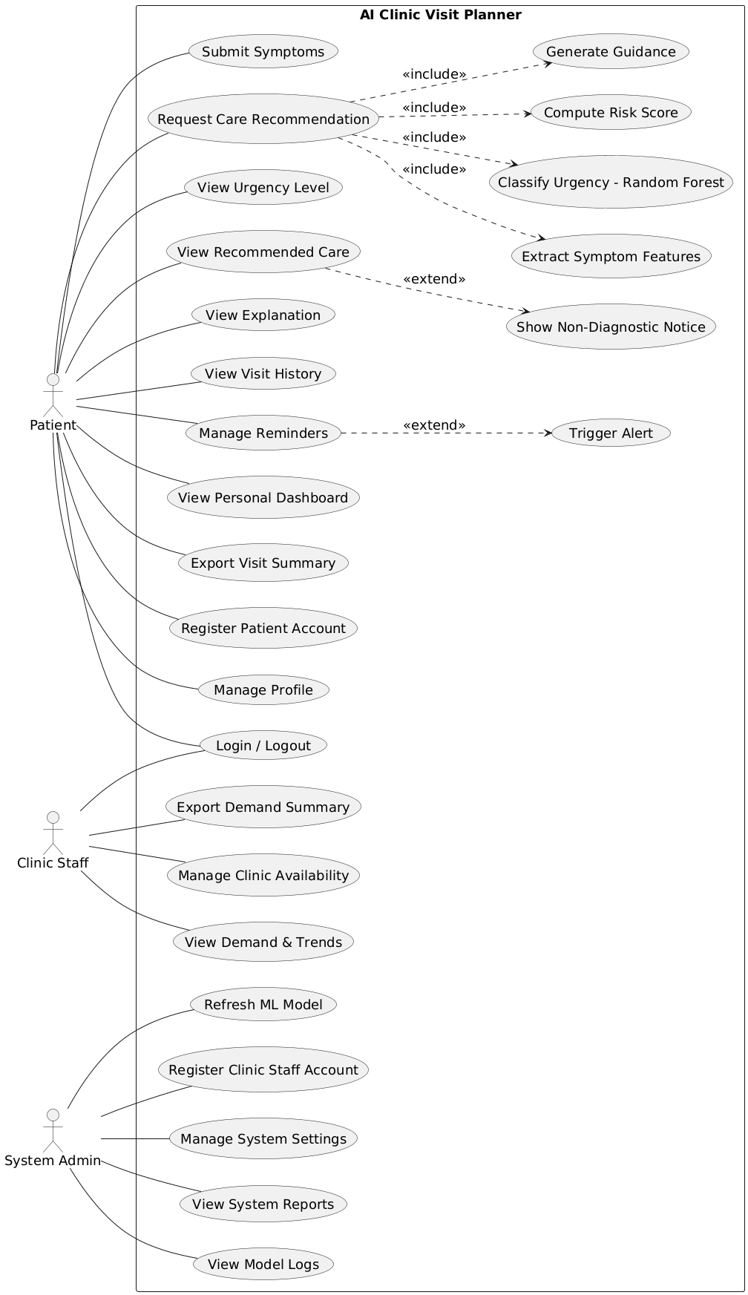
Figure.1 Use Case Diagram

2. Use Case Description

1. Submit Symptoms
Actor: Patient
Related Functional Requirements: 7, 8, 9, 10
Trigger:
The patient selects the option to submit symptoms from the system menu.
Preconditions:
The patient is logged into the system.
The patient has access to the symptom submission form.
Postconditions:
The symptom description, duration, and basic health details are stored in the system database.
The submitted data is available for later analysis and recommendation.
Normal Flow:
The patient opens the symptom submission form.
The patient enters the symptom description in the text field.
The patient selects the symptom duration.
The patient enters age and basic health details.
The patient submits the form.
The system validates the entered information.
The system stores the symptom record successfully.
The system confirms that the submission is complete.
Exception Flow:
If required fields are empty, the system highlights missing fields.
If invalid values are entered, the system shows an error message.
The patient corrects the input and resubmits the form.

2. Request Care Recommendation
Actor: Patient
Related Functional Requirements: 12
Trigger:
The patient selects the option to request a care recommendation.
Preconditions:
The patient is logged into the system.
At least one symptom record exists for the patient.
Postconditions:
The system starts the recommendation process.
The system prepares the data for analysis by internal AI components.
Normal Flow:
The patient selects the request recommendation option.
The system retrieves the latest symptom submission.
The system confirms that the data is ready for processing.
The system starts the internal analysis workflow.
The system moves to urgency classification and guidance generation.
The system notifies the patient that analysis is in progress.
Exception Flow:
If no symptom data is available, the system displays a warning.
The patient is asked to submit symptoms before requesting recommendations.

3. View Urgency Level
Actor: Patient
Related Functional Requirements: 17
Trigger:
The system completes the urgency classification process.
Preconditions:
The patient has requested a care recommendation.
The urgency level has been calculated by the system.
Postconditions:
The urgency category is displayed to the patient.
Normal Flow:
The system retrieves the urgency result for the patient.
The system displays the urgency level as Low, Medium, or High.
The patient reviews the urgency category.
The system logs that the result was viewed.
Exception Flow:
If the urgency result is not available, the system shows an error message.
The patient is asked to retry the request later.

4. View Recommended Care
Actor: Patient
Related Functional Requirements: 18
Trigger:
The patient selects the option to view the recommended care.
Preconditions:
The urgency level is already available.
The patient is logged into the system.
Postconditions:
The recommended care option is displayed to the patient.
Normal Flow:
The system retrieves the recommendation result.
The system displays the suggested care option, such as clinic or hospital visit.
The patient reads the recommendation.
The system records that the recommendation was viewed.
Exception Flow:
If the recommendation is missing, the system shows a message.
The patient is asked to request the recommendation again.

5. View Explanation
Actor: Patient
Related Functional Requirements: 19
Trigger:
The patient selects the option to view the explanation for the recommendation.
Preconditions:
A recommendation result is available.
The patient is logged into the system.
Postconditions:
The explanation for the recommendation is displayed.
Normal Flow:
The system retrieves the explanation text.
The system displays simple reasons for the recommendation.
The patient reads the explanation.
The system records that the explanation was viewed.
Exception Flow:
If explanation text is not available, the system shows a notice.
The patient is informed that explanation cannot be displayed.

6. View Visit History
Actor: Patient
Related Functional Requirements: 11, 13
Trigger:
The patient opens the visit history page.
Preconditions:
The patient is logged into the system.
Visit records exist in the system.
Postconditions:
The visit history is displayed to the patient.
Normal Flow:
The system retrieves stored visit records.
The system displays the list of previous visits.
The patient reviews past visit information.
The system logs the access to visit history.
Exception Flow:
If no records are found, the system shows an empty history message.
The patient is informed that no previous visits exist.

7. Manage Reminders
Actor: Patient
Related Functional Requirements: 20, 21, 22, 23, 38, 39
Trigger:
The patient opens the reminder management option.
Preconditions:
The patient is logged into the system.
Postconditions:
Reminder settings are saved or updated.
Future alerts are scheduled based on user settings.
Normal Flow:
The patient selects to create or update a reminder.
The patient enters date and time for the reminder.
The patient chooses to opt in or opt out of reminders.
The system saves the reminder settings.
The system schedules alerts based on the saved data.
The patient receives confirmation of reminder settings.
Exception Flow:
If the date or time is invalid, the system displays an error.
The patient corrects the information and resubmits.

8. View Personal Dashboard
Actor: Patient
Related Functional Requirements: 24, 25
Trigger:
The patient opens the dashboard page.
Preconditions:
The patient is logged into the system.
Visit and trend data exist in the system.
Postconditions:
The personal dashboard is displayed.
Normal Flow:
The system retrieves visit history and trend data.
The system displays charts and summaries.
The patient reviews personal health trends.
The system logs that the dashboard was accessed.
Exception Flow:
If data is unavailable, the system shows a message.
The patient is informed that the dashboard cannot load.

9. Export Visit Summary
Actor: Patient
Related Functional Requirements: 33
Trigger:
The patient selects the option to export the visit summary.
Preconditions:
The patient is logged into the system.
At least one visit record exists for the patient.
Postconditions:
A visit summary report is generated and downloaded.
The exported file is available to the patient for reference.
Normal Flow:
The patient opens the export option on the visit history page.
The system collects the patient’s visit records.
The system formats the data into a summary report.
The system generates the export file.
The patient downloads the report to the device.
The system confirms successful export.
Exception Flow:
If export fails, the system displays an error message.
The patient is asked to retry the export later.

10. Register Patient Account
Actor: Patient
Related Functional Requirements: 1
Trigger:
The patient selects the register option on the system home page.
Preconditions:
The patient does not have an existing account.
Postconditions:
A new patient account is created in the system.
The patient can log in using the new credentials.
Normal Flow:
The patient opens the registration form.
The patient enters personal details and credentials.
The system validates the entered information.
The system creates the patient account.
The system confirms successful registration.
The patient is redirected to the login page.
Exception Flow:
If required fields are missing, the system highlights errors.
If the account already exists, the system shows a message.

11. Manage Profile
Actor: Patient
Related Functional Requirements: 26
Trigger:
The patient selects the profile management option.
Preconditions:
The patient is logged into the system.
Postconditions:
The patient profile details are updated and saved.
Normal Flow:
The patient opens the profile page.
The patient edits personal details.
The patient submits the updated information.
The system validates the new values.
The system saves the updated profile.
The system confirms the update.
Exception Flow:
If invalid values are entered, the system shows an error.
The patient corrects the input and resubmits.

12. Login / Logout
Actor: Patient, Clinic Staff
Related Functional Requirements: 2, 5, 6
Trigger:
The user selects login or logout from the system interface.
Preconditions:
The user has a valid account.
Postconditions:
The user is logged into or out of the system.
Normal Flow:
The user enters login credentials.
The system verifies the credentials.
The system grants access to the user.
The user logs out when finished.
The system ends the user session.
Exception Flow:
If credentials are incorrect, the system shows an error message.
If login fails repeatedly, the system restricts access.

13. Generate Guidance (Included Use Case)
Actor: System
Related Functional Requirements: 16
Trigger:
The care recommendation process requires guidance generation.
Preconditions:
Urgency level and risk score are available.
Postconditions:
Plain guidance text is generated for the patient.
Normal Flow:
The system receives the urgency category.
The system applies the rule engine.
The system generates human-readable guidance.
The system stores the guidance for display.
Exception Flow:
If guidance generation fails, the system logs the error.
The system displays a generic guidance message.

14. Compute Risk Score (Included Use Case)
Actor: System
Related Functional Requirements: 15
Trigger:
The system begins the risk evaluation process.
Preconditions:
Symptom features and visit history are available.
Postconditions:
A weighted risk score is calculated.
Normal Flow:
The system retrieves symptom severity values.
The system retrieves visit history factors.
The system calculates the weighted risk score.
The system stores the risk score result.
Exception Flow:
If required data is missing, the system stops processing.
The system logs the computation error.

15. Classify Urgency – Random Forest (Included Use Case)
Actor: System
Related Functional Requirements: 14
Trigger:
The system starts urgency classification.
Preconditions:
Symptom features are extracted.
Postconditions:
An urgency level is classified.
Normal Flow:
The system loads the trained Random Forest model.
The system inputs symptom features into the model.
The system classifies urgency as Low, Medium, or High.
The system stores the urgency result.
Exception Flow:
If the model fails to load, the system logs the error.
The system notifies that classification failed.

16. Extract Symptom Features (Included Use Case)
Actor: System
Related Functional Requirements: 13
Trigger:
The system begins processing submitted symptoms.
Preconditions:
The patient has submitted symptom data.
Postconditions:
Symptom features are extracted and prepared.
Normal Flow:
The system reads symptom text and duration.
The system identifies keywords and severity values.
The system formats features for model input.
The system stores extracted features.
Exception Flow:
If symptom data is incomplete, the system stops processing.
The system logs the feature extraction error.

17. Show Non-Diagnostic Notice (Extended Use Case)
Actor: System
Related Functional Requirements: 35
Trigger:
The system prepares to display guidance results to the patient.
Preconditions:
A recommendation and guidance text are available.
The patient is viewing the recommendation result page.
Postconditions:
The non-diagnostic notice is displayed with the guidance.
Normal Flow:
The system loads the guidance content.
The system displays the non-diagnostic notice on the result screen.
The patient reads the notice.
The system records that the notice was shown.
Exception Flow:
If the notice text is missing, the system displays a default notice.
The system logs the missing notice content.

18. Trigger Alert (Extended Use Case)
Actor: System
Related Functional Requirements: 23
Trigger:
The scheduled reminder time matches the current system time.
Preconditions:
The patient has opted in to reminders.
A reminder schedule exists in the system.
Postconditions:
An alert is sent to the patient.
Normal Flow:
The system checks reminder schedules.
The system identifies due reminders.
The system sends alert notifications to the patient.
The system records that the alert was sent.
Exception Flow:
If alert delivery fails, the system logs the error.
The system retries sending the alert later.

19. Export Demand Summary
Actor: Clinic Staff
Related Functional Requirements: 40
Trigger:
Clinic staff selects the export demand summary option.
Preconditions:
Clinic staff is logged into the system.
Demand data exists in the system.
Postconditions:
A demand summary file is generated and downloaded.
Normal Flow:
Clinic staff opens the export option.
The system retrieves anonymized demand data.
The system formats the data into a summary report.
The system generates the export file.
Clinic staff downloads the file.
The system confirms successful export.
Exception Flow:
If export fails, the system displays an error message.
Clinic staff is asked to retry later.

20. Manage Clinic Availability
Actor: Clinic Staff
Related Functional Requirements: 36, 37
Trigger:
Clinic staff selects the clinic availability option.
Preconditions:
Clinic staff is logged into the system.
Postconditions:
Clinic service availability and operating hours are updated.
Normal Flow:
Clinic staff opens availability settings.
Clinic staff updates clinic service options.
Clinic staff updates clinic operating hours.
The system validates the entered data.
The system saves the updated availability details.
The system confirms the update.
Exception Flow:
If invalid hours are entered, the system displays an error.
Clinic staff corrects the input and resubmits.

21. View Demand & Trends
Actor: Clinic Staff
Related Functional Requirements: 28, 29
Trigger:
Clinic staff opens the demand and trends page.
Preconditions:
Clinic staff is logged into the system.
Postconditions:
Anonymized demand trends are displayed.
Normal Flow:
The system retrieves anonymized trend data.
The system displays daily demand and trend summaries.
Clinic staff reviews demand patterns.
The system logs access to trend data.
Exception Flow:
If no trend data is available, the system shows a message.
Clinic staff is informed that no data exists.

22. Refresh ML Model
Actor: System Admin
Related Functional Requirements: 31
Trigger:
The system admin selects the refresh model option.
Preconditions:
The system admin is logged into the system.
Postconditions:
The machine learning model is refreshed and updated.
Normal Flow:
The system admin starts the refresh process.
The system loads training data.
The system retrains the model.
The system deploys the updated model.
The system confirms the refresh completion.
Exception Flow:
If refresh fails, the system logs the error.
The system admin is notified of the failure.

23. Register Clinic Staff Account
Actor: System Admin
Related Functional Requirements: 4
Trigger:
The system admin selects the option to create a clinic staff account.
Preconditions:
The system admin is logged into the system.
Postconditions:
A clinic staff account is created.
Normal Flow:
The system admin enters staff details.
The system validates the entered information.
The system creates the staff account.
The system confirms account creation.
Exception Flow:
If staff details are invalid, the system displays an error.
The system admin corrects the information and resubmits.

24. Manage System Settings
Actor: System Admin
Related Functional Requirements: 38
Trigger:
The system admin selects system settings.
Preconditions:
The system admin is logged into the system.
Postconditions:
System configuration settings are updated.
Normal Flow:
The system admin opens system settings.
The system admin updates configuration values.
The system validates the new values.
The system saves the settings.
The system confirms the update.
Exception Flow:
If invalid values are entered, the system rejects the update.
The system admin is asked to correct the input.

25. View System Reports
Actor: System Admin
Related Functional Requirements: 39
Trigger:
The system admin selects view system reports.
Preconditions:
The system admin is logged into the system.
Postconditions:
System usage reports are displayed.
Normal Flow:
The system retrieves usage reports.
The system displays reports to the admin.
The admin reviews the reports.
The system logs that reports were viewed.
Exception Flow:
If reports are unavailable, the system shows a message.
The system admin is informed to try again later.

26. View Model Logs
Actor: System Admin
Related Functional Requirements: 30
Trigger:
The system admin opens model logs.
Preconditions:
The system admin is logged into the system.
Postconditions:
Model performance logs are displayed.
Normal Flow:
The system retrieves model logs.
The system displays logs to the admin.
The admin reviews model performance data.
The system logs that model logs were viewed.
Exception Flow:
If logs cannot be loaded, the system shows an error.
The system admin is informed that logs are unavailable.

3. Activity Diagram
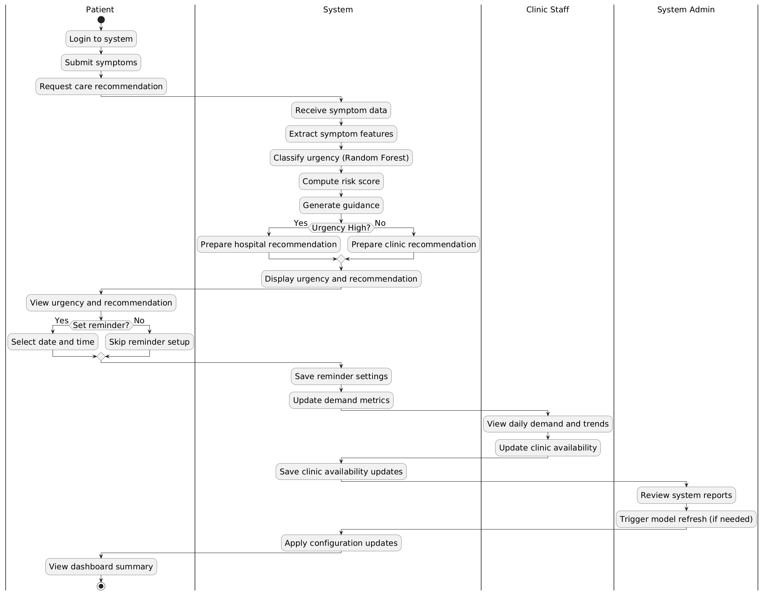
Figure.2 Activity Diagram

